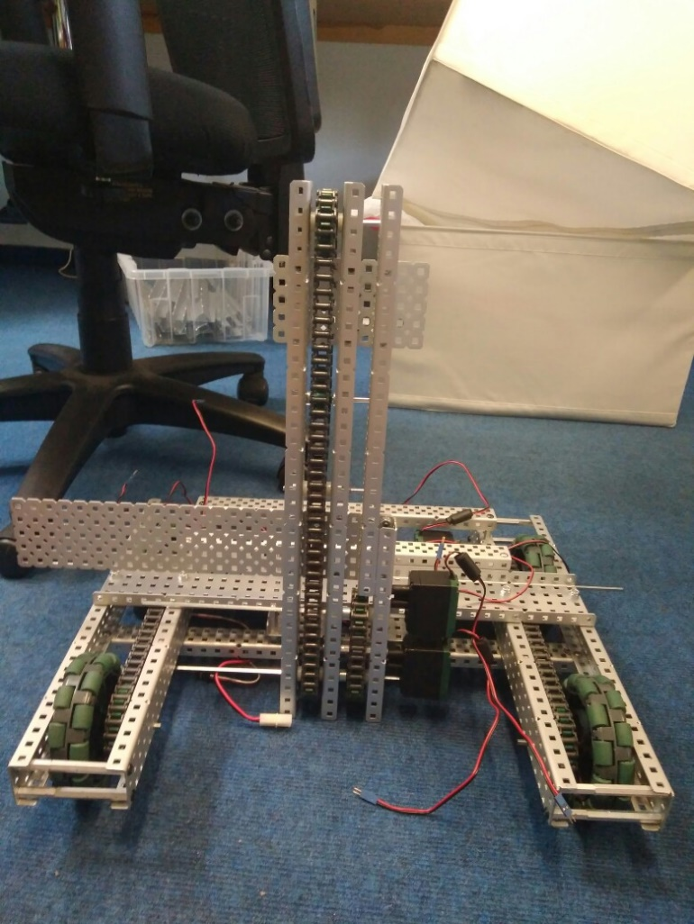

By Robbie Buxton

4/7/2017 – 17:19

**Overview:**

For this version of the robot we have had our first crack and building the first stage of our 3 stage elevator lift we plan to use for picking up cones and mobile goals. We make the first prototype version using non-nylocs so it needs to be remade with them. We also need to create two more stages of the lift and add two more motors so the lift is a four-motor lift. After that we need to attach it to the robot. We would normally make the claw first but seeing as our field elements have not arrived yet we have decided to build the lift first.

**What needs to be changed:**

* Remake the first stage using nylocs
* Add two more stages
* Attach first stage to robot
* Add two more motors to lift

**WHAT HAS BEEN CHANGED:**

* Added the first prototype of the lift mechanism (not actually attached)

SPECIFICATIONS:

* 6 Motor HS drive
* Two drive chains
* 4 wheels
* Aluminium structure
* 2 motor lift

DIMENTIONS:

17.5” * 15”

Robot V 1.13